FEDERAL MINISTRY OF HEALTH
[Annual Review Meeting]

CALL FOR EXPRESSION OF INTEREST (EOI)

Exhibition Booth Participation at the Central Ethiopia, Hossana Health Sector Annual Review Meeting (ARM)

Theme: “Transformative Reform for a Sovereign and Resilient Health System”

Venue: Hossana Cultural Hall, Central Ethiopia
Date: October 21–23, 2026

1. About the Annual Health Sector Review Meeting (ARM)

The Federal Ministry of Health (MOH) organizes the Health Sector Annual Review Meeting (ARM) each year following the close of the fiscal year. The ARM is the sector’s flagship national gathering, bringing together the Ministry of Health, Regional Health Bureaus, hospitals and health facilities, universities and research institutions, professional associations, implementing partners, donors, development partners, the private sector, and other health-sector stakeholders.

The ARM provides a platform to review the health sector’s performance over the preceding year, share best practices and lessons learned, recognize achievements and challenges, and establish shared priorities and targets for the year ahead in line with Ethiopia’s health-sector development plans, national health strategies, and reform agenda.

The 2026 ARM, under the theme “Transformative Reform for a Sovereign and Resilient Health System,” will place particular emphasis on transformative reforms, local capacity and solutions, sustainable health financing, domestic production and supply systems, innovation, evidence-based decision-making, resilient health services, and strategic partnerships that contribute to a stronger and more self-reliant health system.

The exhibition will be held alongside the ARM, providing exhibitors with direct visibility and engagement with senior health-sector leaders, regional health officials, health facility leadership, development partners, innovators, private-sector actors, researchers, and other key stakeholders from across the country.

2. Purpose of the Exhibition

The Federal Ministry of Health (MOH) is pleased to invite health-sector stakeholders to express their interest in exhibiting at the upcoming Health Sector Annual Review Meeting in Hossana.

Under the theme “Transformative Reform for a Sovereign and Resilient Health System,” the exhibition will provide a platform to showcase achievements, testimonies, innovations, evidence, lessons learned, ongoing initiatives, and transformative reforms resulting from collaborative efforts to strengthen Ethiopia’s health system.

The exhibition will highlight how the MOH, Regional Health Bureaus, government agencies, hospitals and health facilities, private-sector innovators, academic and research institutions, implementing partners, donors, and other stakeholders are working together to advance national health priorities and build a stronger, more resilient, sustainable, innovative, and increasingly sovereign health system.

Exhibitors are particularly encouraged to demonstrate tangible contributions in areas such as:

Local manufacturing and pharmaceutical, medical supply, and technology production

Health financing, CBHI and sustainable investment

Digital health and technological innovation

Health workforce development and capacity strengthening

Quality of care and patient satisfaction

Disease prevention (controlled, Eliminated)

health emergency resilience

Research, evidence generation, and knowledge translation (Action research)

Innovation and locally developed solutions

LMIS management improved, Supply-chain resilience

Public-private partnerships and strategic collaboration

Community engagement and people-centered health services

Successful models that can be scaled nationally or regionally

Health-system transformation and institutional reform

Local solutions, domestic capacity, and health-system sovereignty

3. Exhibitor Benefits
Participation in the exhibition will provide exhibitors with:

Direct visibility and engagement with senior health-sector leaders, Regional Health Bureau heads, Ministry of Health officials, health facility leaders, and other key decision-makers.

An opportunity to showcase achievements, testimonies, impact, innovations, and lessons learned from collaborative initiatives contributing to the transformation of Ethiopia’s health system.

A platform to demonstrate ongoing and successful joint projects implemented in collaboration with the Ministry of Health, RHBs, government agencies, health facilities, private-sector actors, academia, research institutions, implementing partners, and donors.

An opportunity to demonstrate contributions to health-system sovereignty and resilience, including local solutions, domestic production, local capacity development, innovation, sustainable financing, and strengthened health-system institutions.

An opportunity to share evidence, innovations, best practices, and experiences demonstrating how partnerships are addressing national and regional health priorities and supporting transformative reform.

Networking and partnership-building opportunities with government institutions, implementing partners, donors, academia, private-sector innovators, manufacturers, health facilities, and other stakeholders from across the country.

An opportunity to highlight tangible contributions and measurable results toward Ethiopia’s national health priorities, strategies, and reform agenda.

Recognition and visibility as a collaborative partner contributing to the advancement, transformation, sovereignty, and resilience of Ethiopia’s health system.

An opportunity to identify and promote future areas of collaboration, scale-up, investment, technology transfer, and technical or financial support based on demonstrated results and ongoing initiatives.

A platform for collective learning and knowledge exchange, enabling stakeholders to share experiences, successes, challenges, innovations, and approaches to building a more resilient and self-reliant health system.

4. Sample Booth Layouts

The illustrations below show indicative booth layouts by size category. Final booth specifications, branding requirements, technical standards, and build guidelines will be shared with selected exhibitors.

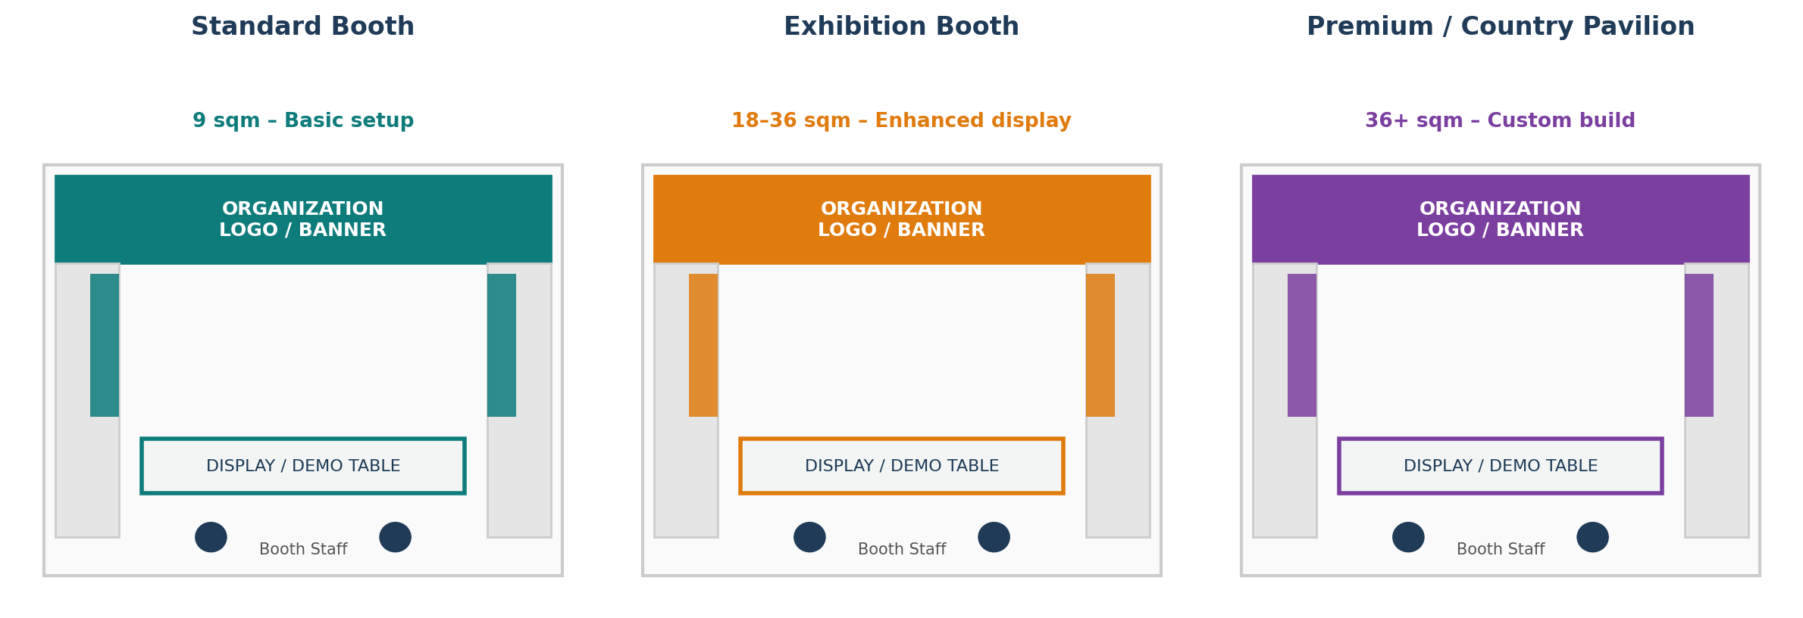

5. Who Can Apply

The call is open to health-sector stakeholders whose work contributes to Ethiopia’s health-sector transformation and the theme of “Transformative Reform for a Sovereign and Resilient Health System,” including:

Private-sector companies and innovators contributing to health-sector improvement, local solutions, manufacturing, technology, service delivery, or health-system transformation.

Academic and research institutions generating evidence, research, innovations, technologies, and knowledge that contribute to health-sector reform and improved health outcomes.

Government health agencies and Regional Health Bureaus (RHBs) implementing health programs, reforms, innovations, and initiatives aligned with national and regional priorities.

Hospitals and health facilities demonstrate successful experiences, innovations, quality-improvement initiatives, service-delivery models, and measurable results.

Implementing partners supporting health-sector programs, reforms, innovations, and collaborative initiatives.

Donors and development partners provide technical, financial, strategic, or other support to health-sector transformation and resilience.

6. Participation Criteria

Cost of Participation: All exhibition-related costs, including booth design, construction and setup, staffing, exhibition materials, branding, transportation, and other associated expenses, shall be covered by the exhibitor. The Ministry of Health will not cover or reimburse these costs.

Private-Sector Exhibitors: Private-sector entities shall participate in collaboration with MOH, RHBs, government agencies, and/or health facilities and may showcase relevant products, services, technologies, innovations, achievements, and contributions through the joint exhibition.

Implementing Partners and Donors: Implementing partners and donors shall participate jointly with MOH (EO/LEO), RHBs, government agencies, and/or health facilities, demonstrating their collaboration, support, achievements, testimonies, and evidence, and ongoing projects. They should not exhibit independently. All exhibition content and activities must align with national health-sector strategies, priorities, reforms, and the ARM theme.

Alignment with the ARM Theme: Proposed exhibitions should demonstrate a clear and meaningful contribution to “Transformative Reform for a Sovereign and Resilient Health System.” Preference may be given to exhibitions that demonstrate tangible results, locally led solutions, innovation, sustainability, measurable impact, strengthened domestic capacity, health-system resilience, and potential for scale-up or replication.

Exhibition Standards: Booth specifications, layout, branding requirements, technical standards, content guidelines, and other exhibition requirements will be shared with selected exhibitors.

7. Selection and Confirmation of Exhibitors

Submitted expressions of interest will be reviewed by the designated organizing committee based on relevance to the ARM theme, alignment with national health priorities, demonstrated results and impact, innovation, partnership and collaboration, sustainability, and potential contribution to a sovereign and resilient health system.

Selected exhibitors will receive confirmation and further guidance on booth allocation, exhibition specifications, branding, logistics, and other participation requirements.

8. How to Apply
Interested organizations should submit a formal expression of interest, including an organizational profile and a brief description of the products, services, or areas of support to be showcased, along with a signed letter of acceptance confirming agreement to the participation terms above.
Please be advised to include contact details.

9. Key Information
Application Deadline  Within one (1) week of this announcement | Submission Channel  Email address: moh@moh.gov.et
Event Dates  Oct 21–23, 2026 | Venue  Hossana Cultural Hall, Central Ethiopia
Contact Person  Dawit Berhanu | Contact Details  0970075785

The Ministry of Health reserves the right to review, select, and confirm exhibitors based on relevance, alignment with national health strategies, and available exhibition space.
Federal Ministry of Health — Ethiopia

